CLASS ASSIGNMENT

MODULE 3 DBT

Q 1.

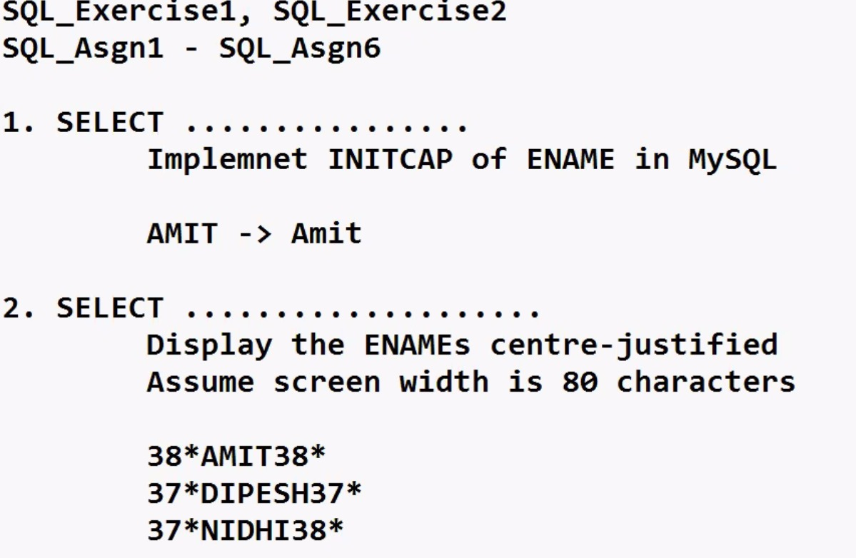  
  
  
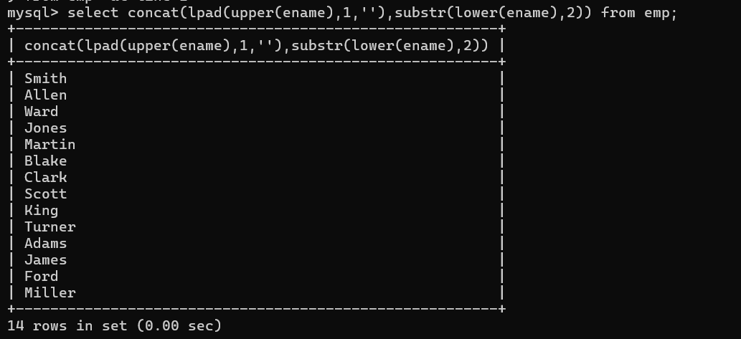

Q. 2..



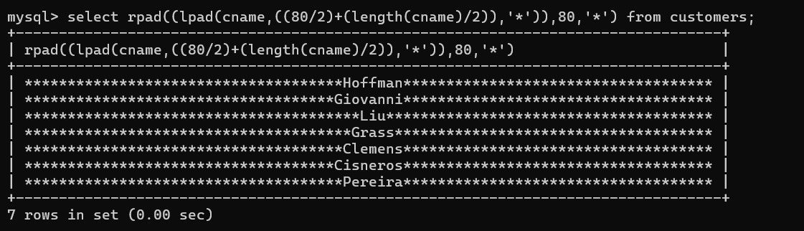

Q. 3.

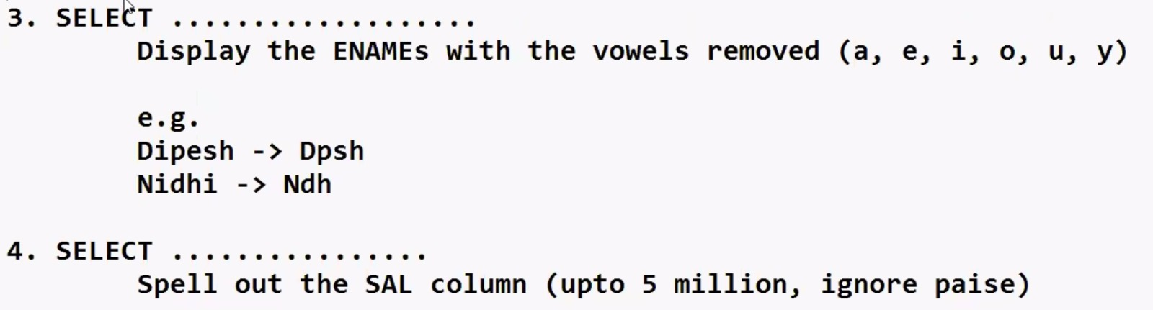

SELECT REPLACE (REPLACE(REPLACE(REPLACE(REPLACE(ENAME,'U',''),'O',''),'I',''),'E',''),'A','') AS NAME_CON FROM EMP;

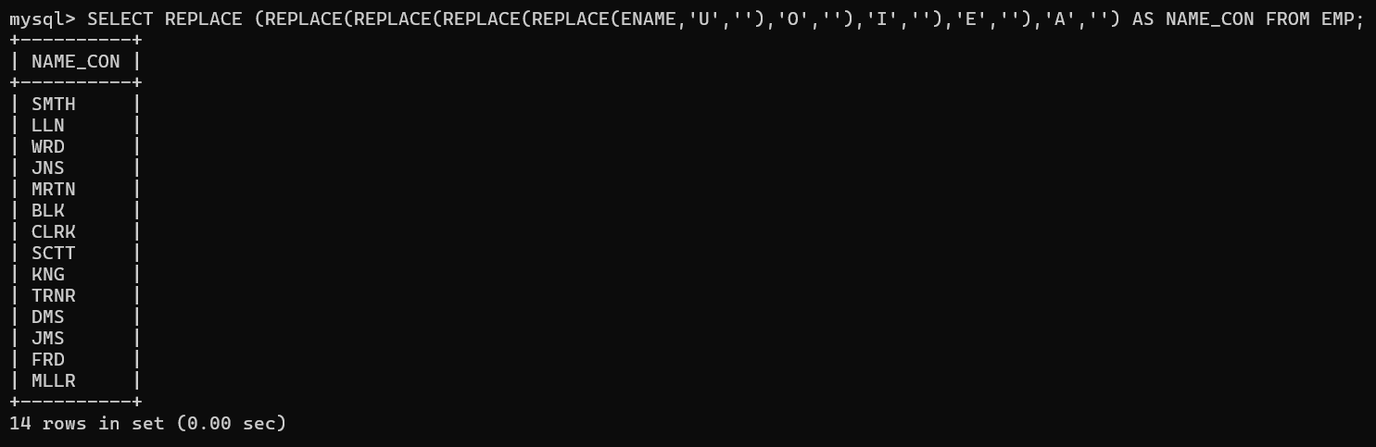

Q.4.

